UNITED STATES
SECURITIES AND EXCHANGE COMMISSION
Washington, D.C. 20549

SCHEDULE 14A

Proxy Statement Pursuant to Section 14(a) of
the Securities Exchange Act of 1934
(Amendment No. )

Filed by the Registrant | þ | Filed by a Party other than the Registrant | ◻

Check the appropriate box:

◻ | Preliminary Proxy Statement
◻ | Confidential, for Use of the Commission Only (as permitted by Rule 14a-6(e)(2))
◻ | Definitive Proxy Statement
þ | Definitive Additional Materials
◻ | Soliciting Material under §240.14a-12

ADVANCED ENERGY INDUSTRIES, INC.
(Name of Registrant as Specified In Its Charter)
(Name of Person(s) Filing Proxy Statement, if other than the Registrant)

Payment of Filing Fee (Check all boxes that apply):
þ | No fee required.
◻ | Fee paid previously with preliminary materials.
◻ | Fee computed on table in exhibit required by Item 25(b) per Exchange Act Rules 14a-6(i)(1) and 0-11.

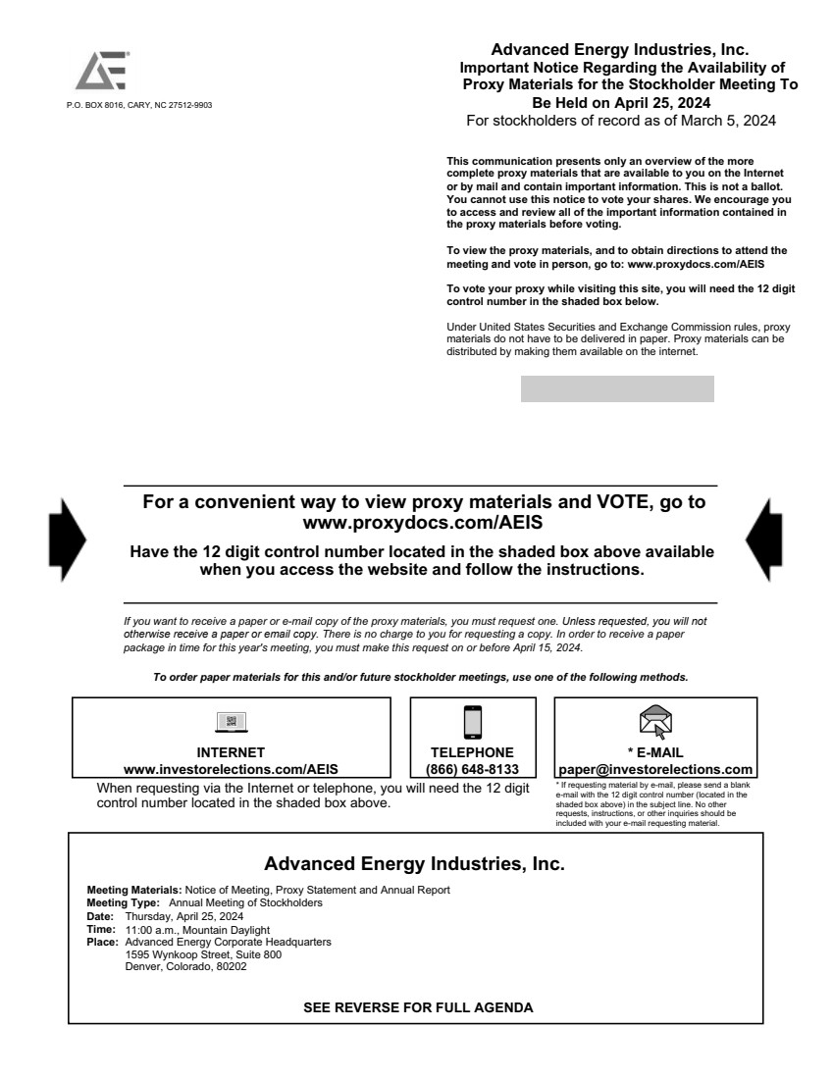 | When requesting via the Internet or telephone, you will need the 12 digit control number located in the shaded box above. * If requesting material by e-mail, please send a blank e-mail with the 12 digit control number (located in the shaded box above) in the subject line. No other requests, instructions, or other inquiries should be included with your e-mail requesting material. Advanced Energy Industries, Inc. Meeting Type: Date: Time: Place: Annual Meeting of Stockholders Thursday, April 25, 2024 11:00 a.m., Mountain Daylight Advanced Energy Corporate Headquarters 1595 Wynkoop Street, Suite 800 Denver, Colorado, 80202 SEE REVERSE FOR FULL AGENDA INTERNET www.investorelections.com/AEIS TELEPHONE (866) 648-8133 * E-MAIL paper@investorelections.com For a convenient way to view proxy materials and VOTE, go to www.proxydocs.com/AEIS Have the 12 digit control number located in the shaded box above available when you access the website and follow the instructions. If you want to receive a paper or e-mail copy of the proxy materials, you must request one. Unless requested, you will not otherwise receive a paper or email copy. There is no charge to you for requesting a copy. In order to receive a paper package in time for this year's meeting, you must make this request on or before April 15, 2024. To order paper materials for this and/or future stockholder meetings, use one of the following methods. Advanced Energy Industries, Inc. Important Notice Regarding the Availability of Proxy Materials for the Stockholder Meeting To Be Held on April 25, 2024 For stockholders of record as of March 5, 2024 This communication presents only an overview of the more complete proxy materials that are available to you on the Internet or by mail and contain important information. This is not a ballot. You cannot use this notice to vote your shares. We encourage you to access and review all of the important information contained in the proxy materials before voting. To view the proxy materials, and to obtain directions to attend the meeting and vote in person, go to: www.proxydocs.com/AEIS To vote your proxy while visiting this site, you will need the 12 digit control number in the shaded box below. Under United States Securities and Exchange Commission rules, proxy materials do not have to be delivered in paper. Proxy materials can be distributed by making them available on the internet. P.O. BOX 8016, CARY, NC 27512-9903 Meeting Materials: Notice of Meeting, Proxy Statement and Annual Report

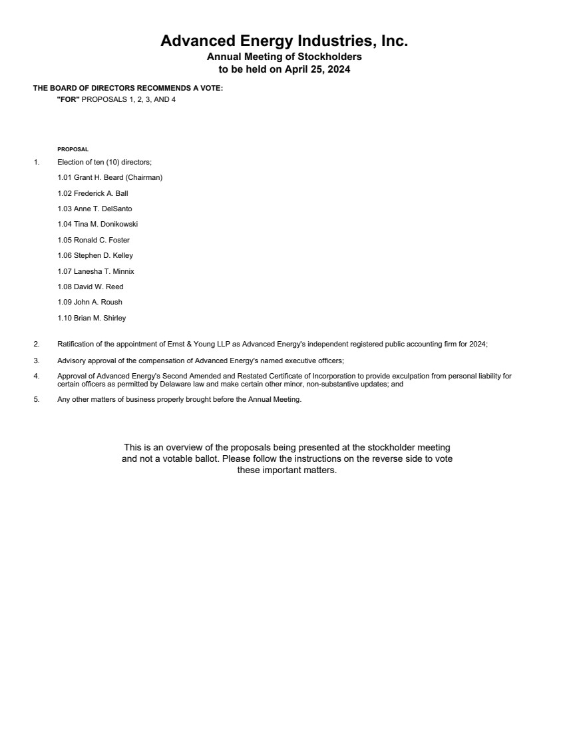 | Advanced Energy Industries, Inc. Annual Meeting of Stockholders to be held on April 25, 2024 PROPOSAL 1. Election of ten (10) directors; 1.01 Grant H. Beard (Chairman) 1.02 Frederick A. Ball 1.03 Anne T. DelSanto 1.04 Tina M. Donikowski 1.05 Ronald C. Foster 1.06 Stephen D. Kelley 1.07 Lanesha T. Minnix 1.08 David W. Reed 1.09 John A. Roush 1.10 Brian M. Shirley 2. Ratification of the appointment of Ernst & Young LLP as Advanced Energy's independent registered public accounting firm for 2024; 3. Advisory approval of the compensation of Advanced Energy's named executive officers; 4. Approval of Advanced Energy's Second Amended and Restated Certificate of Incorporation to provide exculpation from personal liability for certain officers as permitted by Delaware law and make certain other minor, non-substantive updates; and 5. Any other matters of business properly brought before the Annual Meeting. THE BOARD OF DIRECTORS RECOMMENDS A VOTE: "FOR" PROPOSALS 1, 2, 3, AND 4 This is an overview of the proposals being presented at the stockholder meeting and not a votable ballot. Please follow the instructions on the reverse side to vote these important matters.

